Task 1: IPv4 vs. IPv6 Addressing Comparison

Feature / Property | IPv4 Addressing | IPv6 Addressing
Address Length & Space | 32 bits (4 bytes) yielding approximately $2^{32}≈4.3\text{ billion}$ addresses. | 128 bits (16 bytes) yielding approximately $2^{128}≈3.4×{10}^{38}$ addresses.
Format & Notation | Dotted-decimal notation divided into 4 octets (e.g., 192.168.1.1). | Hexadecimal notation divided into 8 groups of 4 digits separated by colons (e.g., 2001:0db8:85a3::8a2e:0370:7334).
Address Configuration | Relies on manual static assignment or dynamic allocation via DHCP. | Supports DHCPv6 as well as stateless automatic autoconfiguration (SLAAC via NDP/Router Advertisements).
Header Complexity & Security | Variable header length (20 to 60 bytes with options); IPsec is optional and relies heavily on NAT to conserve public space. | Fixed-length 40-byte base header for faster routing; designed with built-in end-to-end IPsec support; eliminates the need for NAT.

Task 2: Static IP Allocation Plan (192.168.10.0/24)

- Network Address: 192.168.10.0
- Subnet Mask: 255.255.255.0 (/24)
- Default Gateway (Router): 192.168.10.1

Device | Assigned Static IP | Subnet Mask | Default Gateway
Laptop | 192.168.10.10 | 255.255.255.0 | 192.168.10.1
Smartphone | 192.168.10.11 | 255.255.255.0 | 192.168.10.1
Smart TV | 192.168.10.20 | 255.255.255.0 | 192.168.10.1
Printer | 192.168.10.30 | 255.255.255.0 | 192.168.10.1

Task 3: Subnetting Calculations for 192.168.1.0/27

Calculations:
- Base Network: 192.168.1.0 (Class C default mask is /24)
- Borrowed Subnet Bits ($n$): $27-24=3\text{ bits}$.
- Number of Valid Subnets: $2^{n}=2^{3}=8\text{ subnets}$.
- Host Bits Remaining ($h$): $32-27=5\text{ bits}$.
- Hosts per Subnet (Total): $2^{h}=2^{5}=32\text{ addresses}$.
- Usable Hosts per Subnet: $2^{h}-2=32-2=30\text{ usable hosts}$.
- Block Size (Increment): $256-32=224$ (where mask is 255.255.255.224).
First Three Valid Subnet Ranges:
- Subnet 1:
- Network Address: 192.168.1.0
- Usable Host Range: 192.168.1.1 – 192.168.1.30
- Broadcast Address: 192.168.1.31
- Subnet 2:
- Network Address: 192.168.1.32
- Usable Host Range: 192.168.1.33 – 192.168.1.62
- Broadcast Address: 192.168.1.63
- Subnet 3:
- Network Address: 192.168.1.64
- Usable Host Range: 192.168.1.65 – 192.168.1.94
- Broadcast Address: 192.168.1.95

Task 4: Subnetting Determination for 10.0.5.17 with Mask 255.255.255.0

Step-by-Step Calculation:
- CIDR Notation: 255.255.255.0 corresponds to twenty-four contiguous 1s ($11111111.11111111.{11111111.00000000}_{2}$), which is /24.
- Network Address (Bitwise AND):
- Octet 1: $10\text{ AND }255=10$
- Octet 2: $0\text{ AND }255=0$
- Octet 3: $5\text{ AND }255=5$
- Octet 4: $17\text{ AND }0=0$ (${00010001}_{2}\text{ AND }{00000000}_{2}={00000000}_{2}$)
- Network Address: 10.0.5.0
- Broadcast Address:
- Setting the 8 host bits in the 4th octet to all 1s (${11111111}_{2}=255$).
- Broadcast Address: 10.0.5.255
- Valid Host Range:
- First Usable Host: Network Address + 1 = 10.0.5.1
- Last Usable Host: Broadcast Address – 1 = 10.0.5.254
Summary of Results:
- Network Address: 10.0.5.0
- Broadcast Address: 10.0.5.255
- Valid Host Address Range: 10.0.5.1 – 10.0.5.254

Task 5: Verification via Subnet Calculator

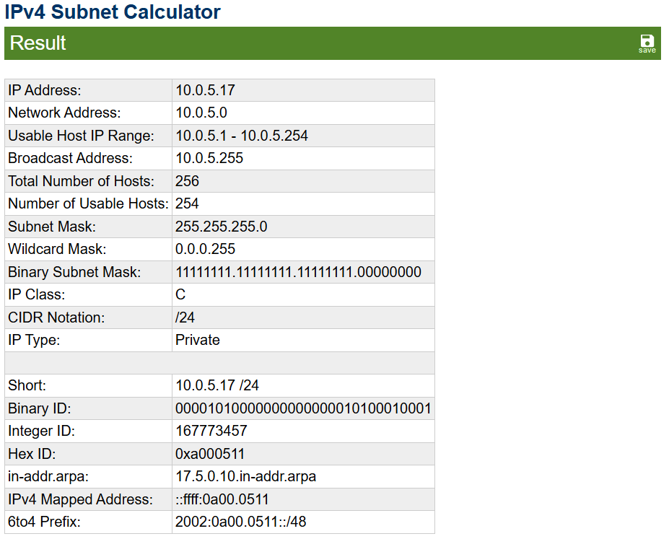
The subnet calculation was verified using an online subnet calculator with the IP address 10.0.5.17 and subnet mask /24.
Verification: The manual calculation matched the subnet calculator output: Network Address 10.0.5.0, Broadcast Address 10.0.5.255, and usable host range 10.0.5.1–10.0.5.254.

